CRUD Operation in SalesForce Using Apex Language

Introduction
Salesforce is a cloud-based Customer Relationship Management (CRM) platform that enables users to build applications with minimal coding. It provides tools for data storage, automation, and business logic implementation using Apex.
In this practical, we developed a Task Management System using Salesforce. A custom object was created, fields were defined, and CRUD (Create, Read, Update, Delete) operations were implemented using Apex.

Objectives
- To understand Salesforce Lightning Platform
- To create and manage custom objects
- To define custom fields using different data types
- To implement CRUD operations using Apex
- To analyze output using Debug Logs

Theory
Salesforce uses a structured data model:
- Objects → Tables
- Fields → Columns
- Records → Rows
- Apex → Programming language for logic
- SOQL → Query language for data retrieval.
CRUD operations in Salesforce:
- Create → Insert records
- Read → Fetch records using SOQL
- Update → Modify existing records
- Delete → Remove records

Practical Implementation
Step 1: Open Salesforce Setup
- Login to Salesforce Developer Edition
- Click on Setup
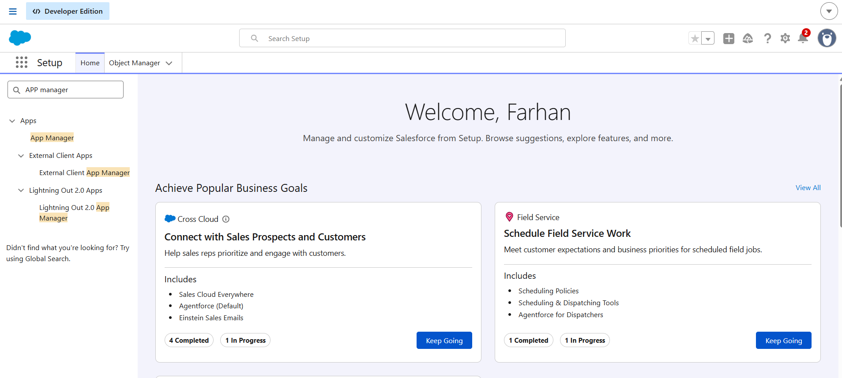
^{Fig 1: Setup Home Screen}
Step 2: Open Object Manager
Navigate to Object Manager from Setup.
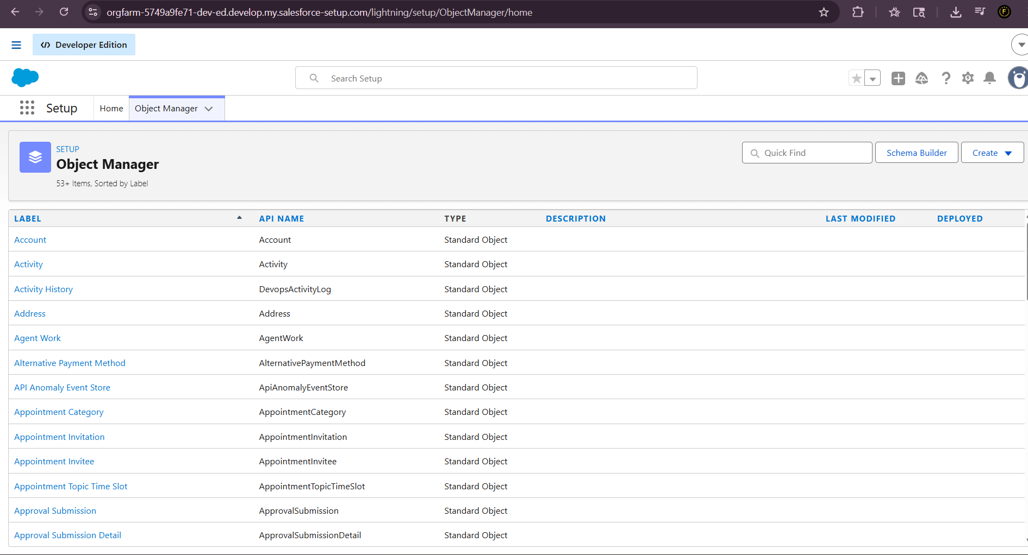
^{Fig 2: Object Manager Page}
Step 3: Create Custom Object
Create a new custom object with:
- Label: Task
- Plural Label: Tasks
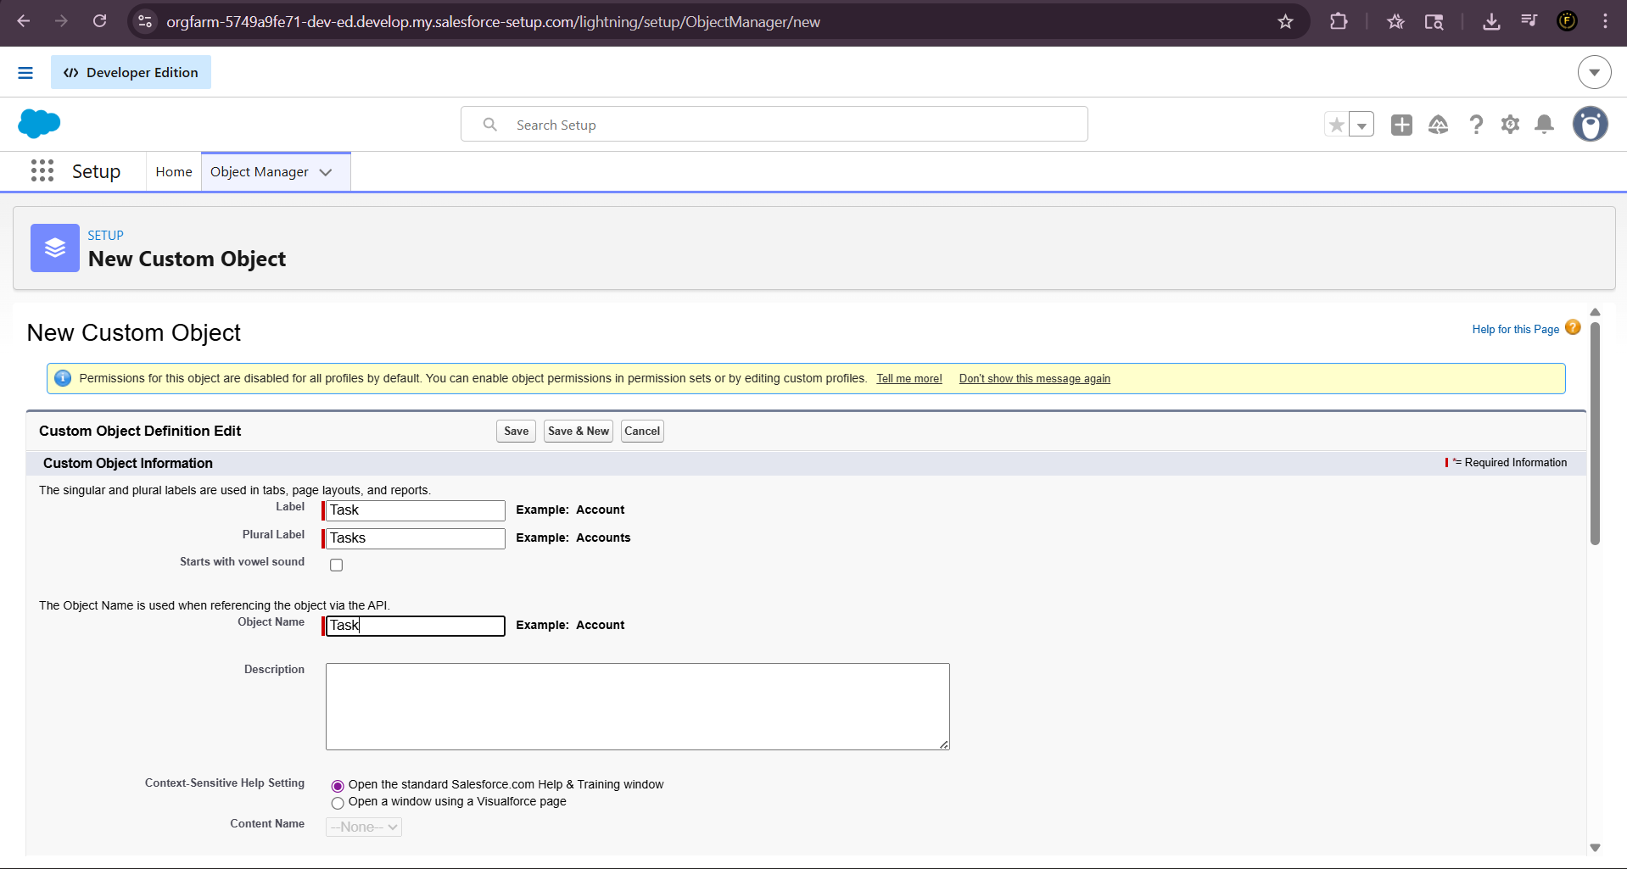
Fig 3: Creating New Custom Object (Task)

Step 4: Create Status Field
Create a Picklist field:
- Field Name: Status
- Values: Pending, Completed

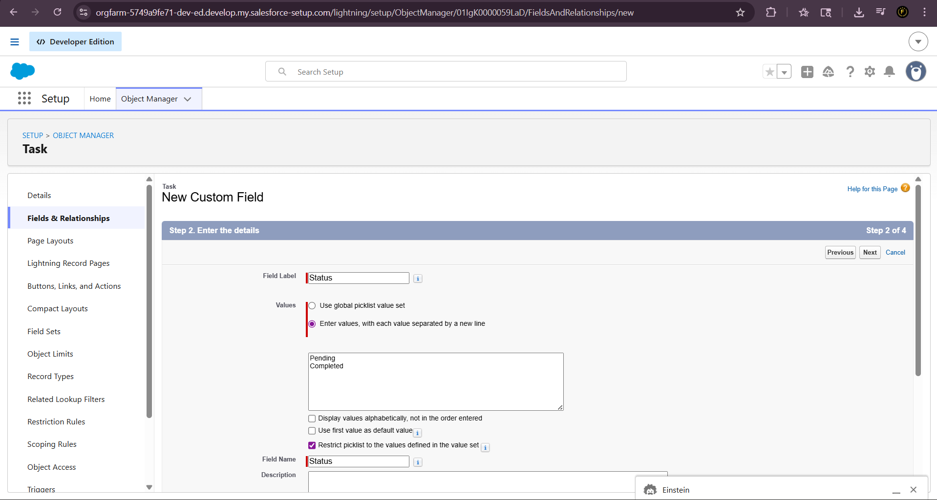
Fig 4: Creating Status Field (Picklist)
Step 5: Add Field to Layout
Add the Status field to the page layout.
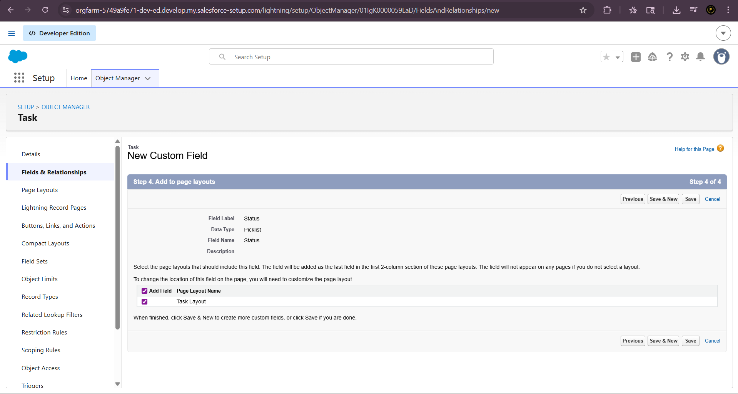
Fig 5: Adding Status Field to Layout

Step 6: Create Priority Field
Create another Picklist field:
- Field Name: Priority
- Values: Low, Medium, High
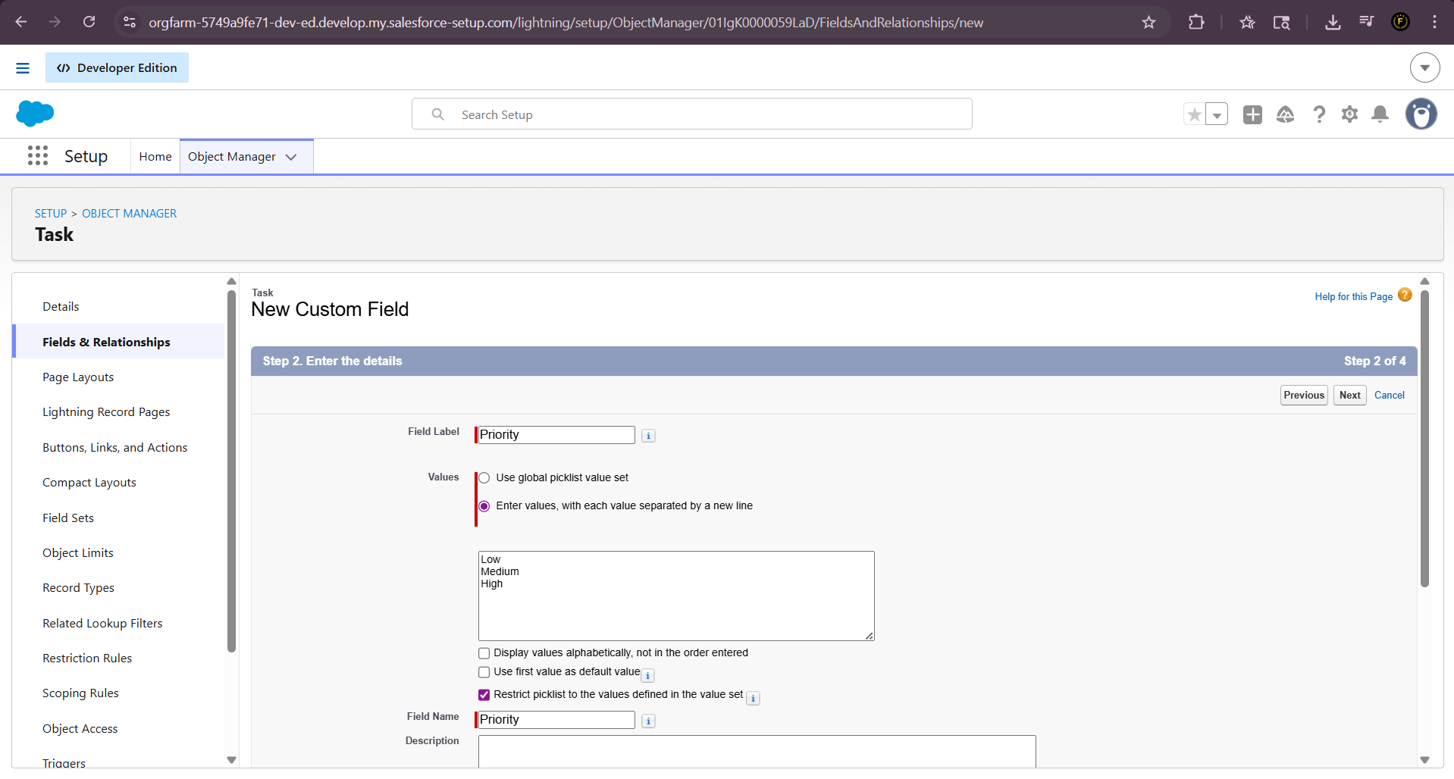
Fig 6: Creating Priority Field (Picklist)
Step 7: View Fields and Relationships
Verify all fields created in the object.
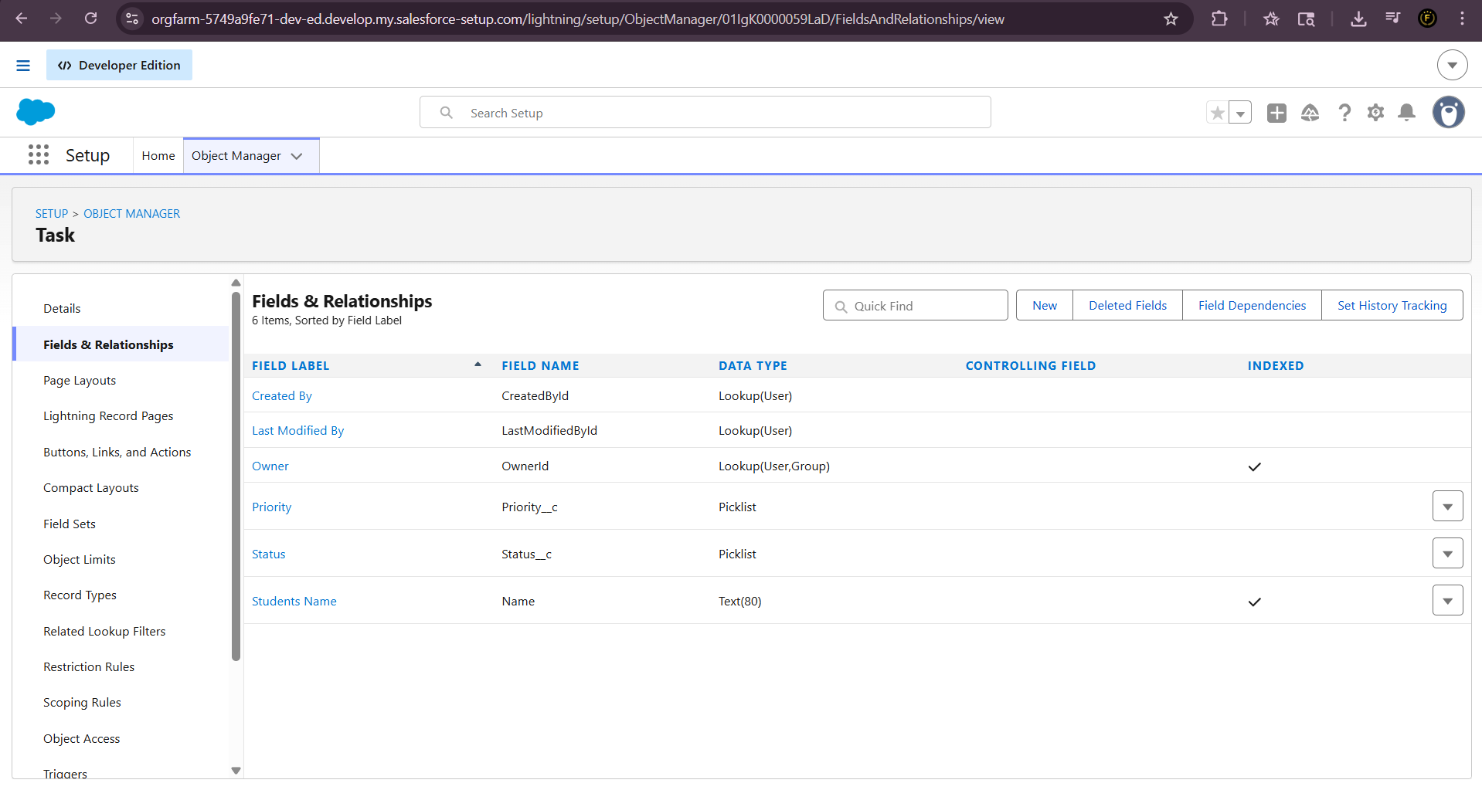
Fig 7: Fields and Relationships Page
Step 8: Create Apex Class
Create an Apex class TaskApp implementing CRUD operations.
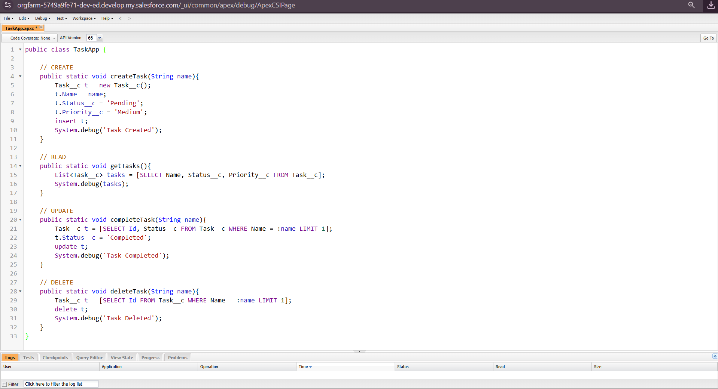
^{Fig 8:} ^{Apex Class for CRUD Operations}

Step 9: Execute Create Operation
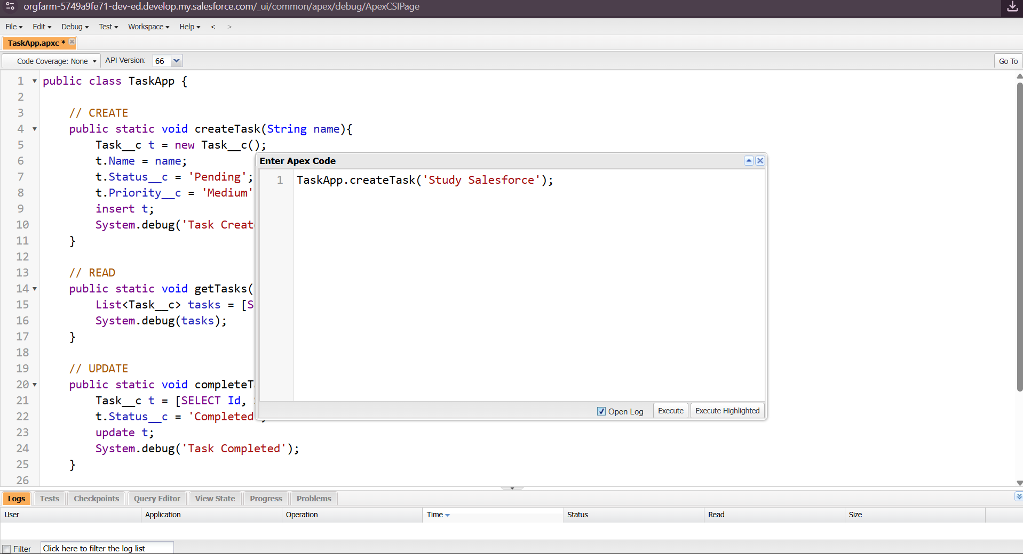
Fig 9.1: Execute Anonymous – Create Task
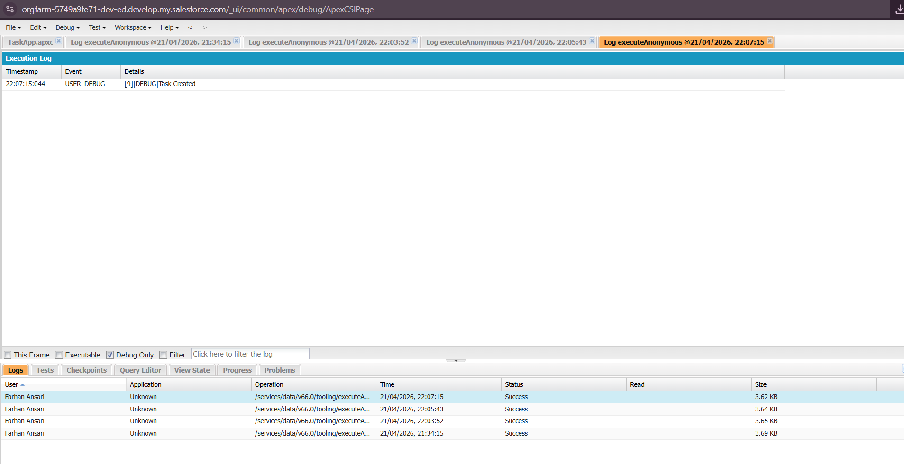
Fig 9.2: Debug Log – Task Completed

Step 10: Read Records
Retrieve all tasks using SOQL.
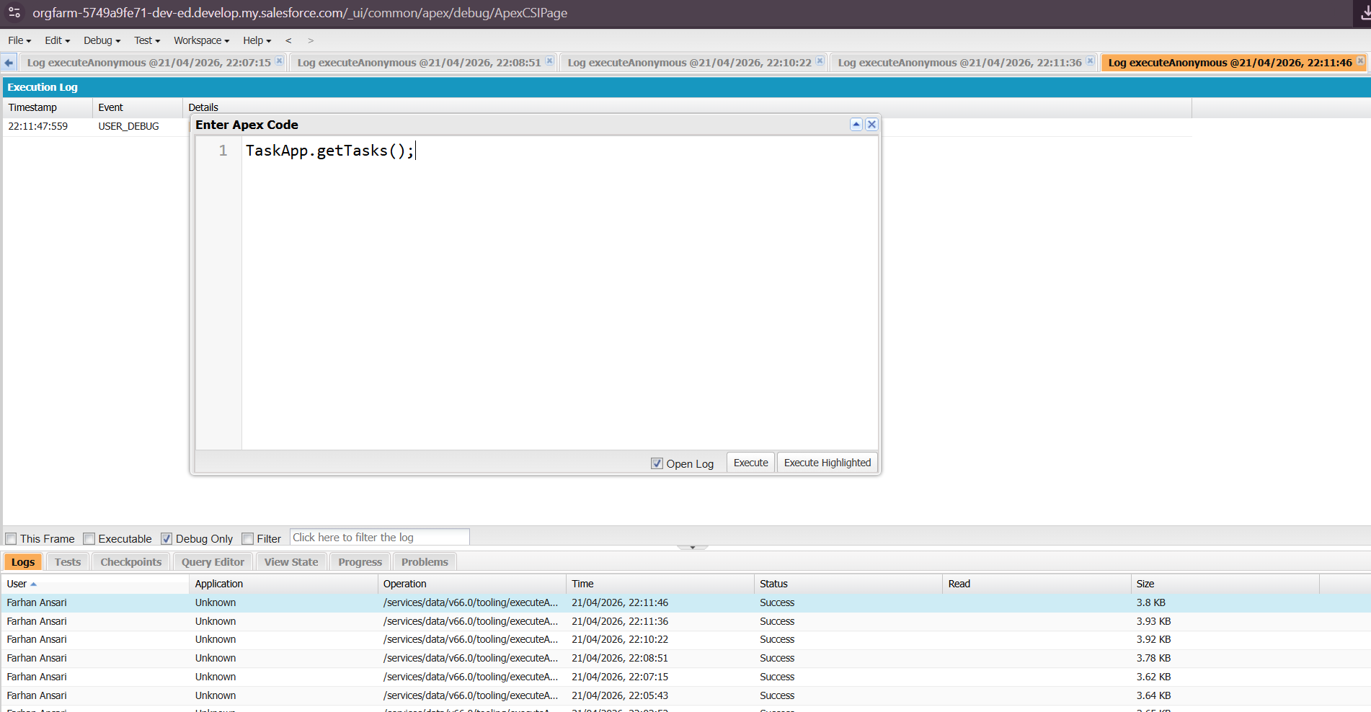
Fig 10.1: Execute Anonymous – Read Task
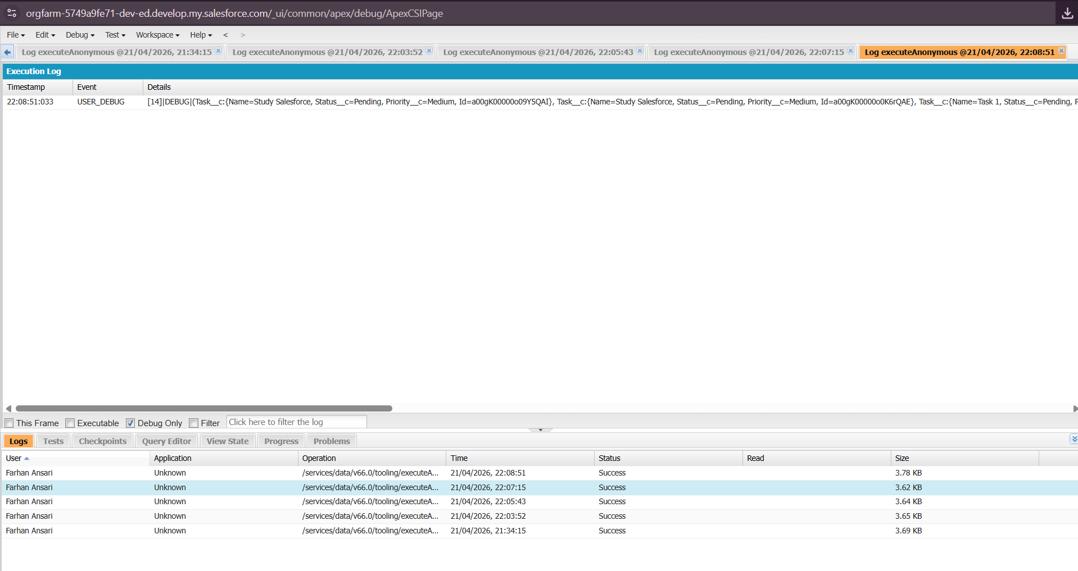
Fig 10.2: Debug Log – Read Operation Output

Step 11: Update Task
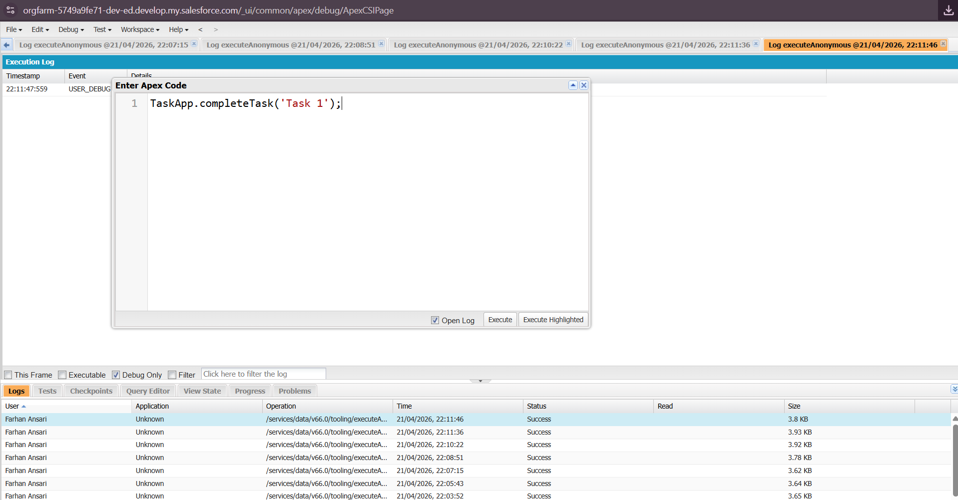
Fig 11.1: Execute Anonymous – Update Task

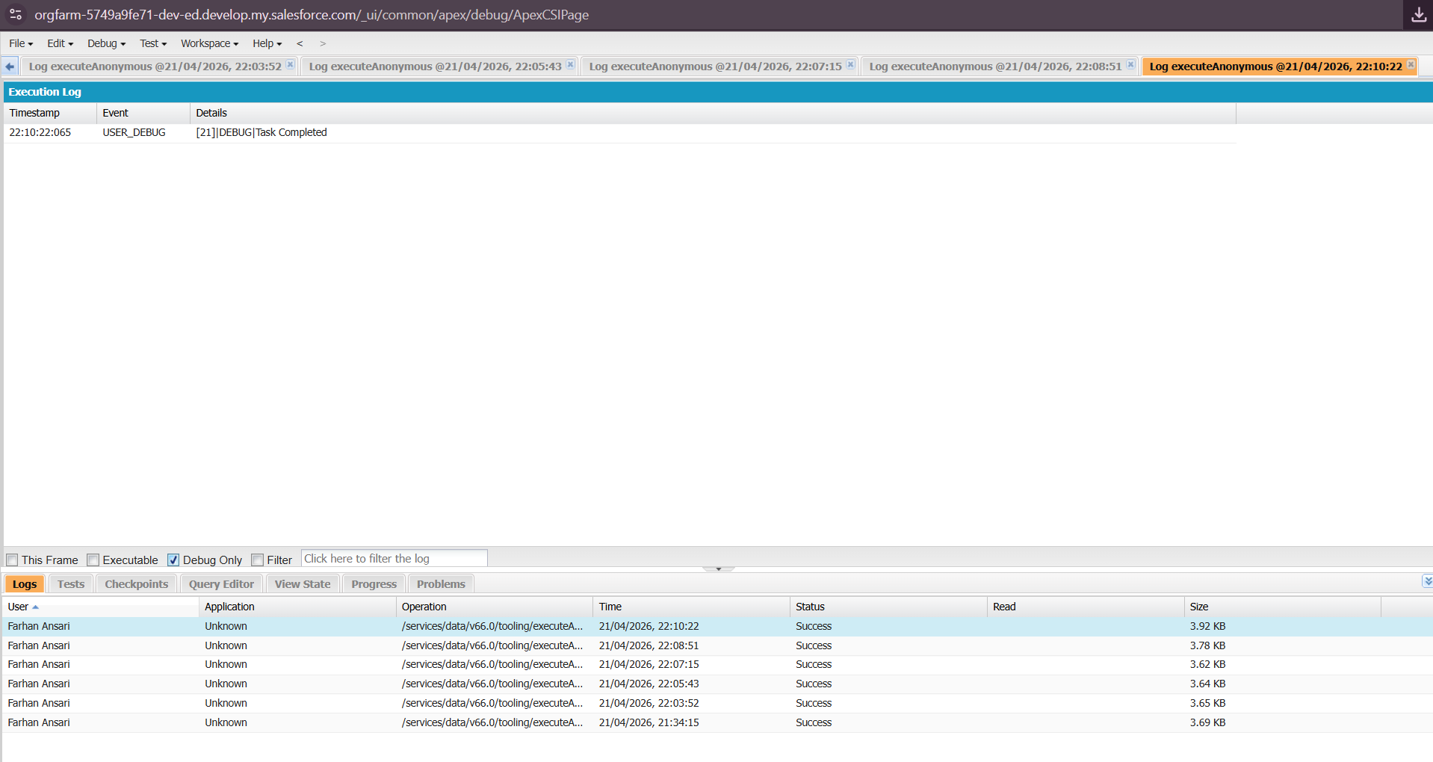
Fig 11.2: Debug Log – Task Completed

Step 12: Delete Task
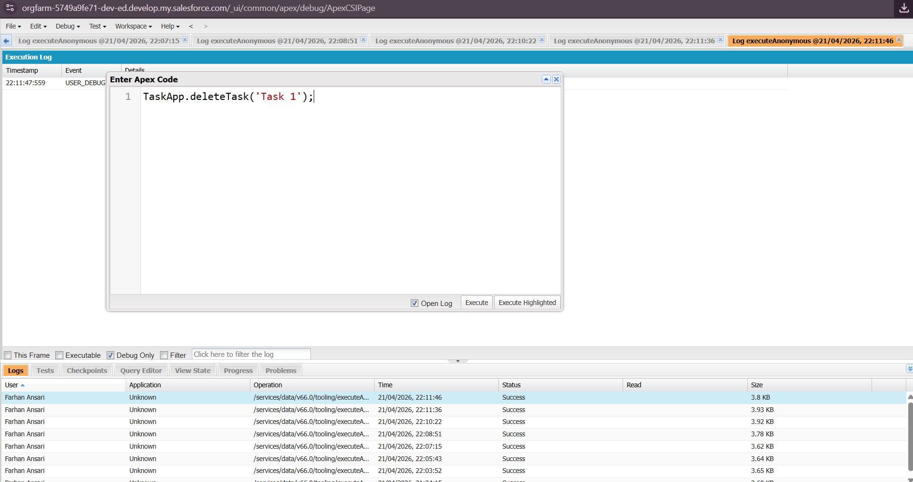
Fig 12.1: Execute Anonymous – Delete Task

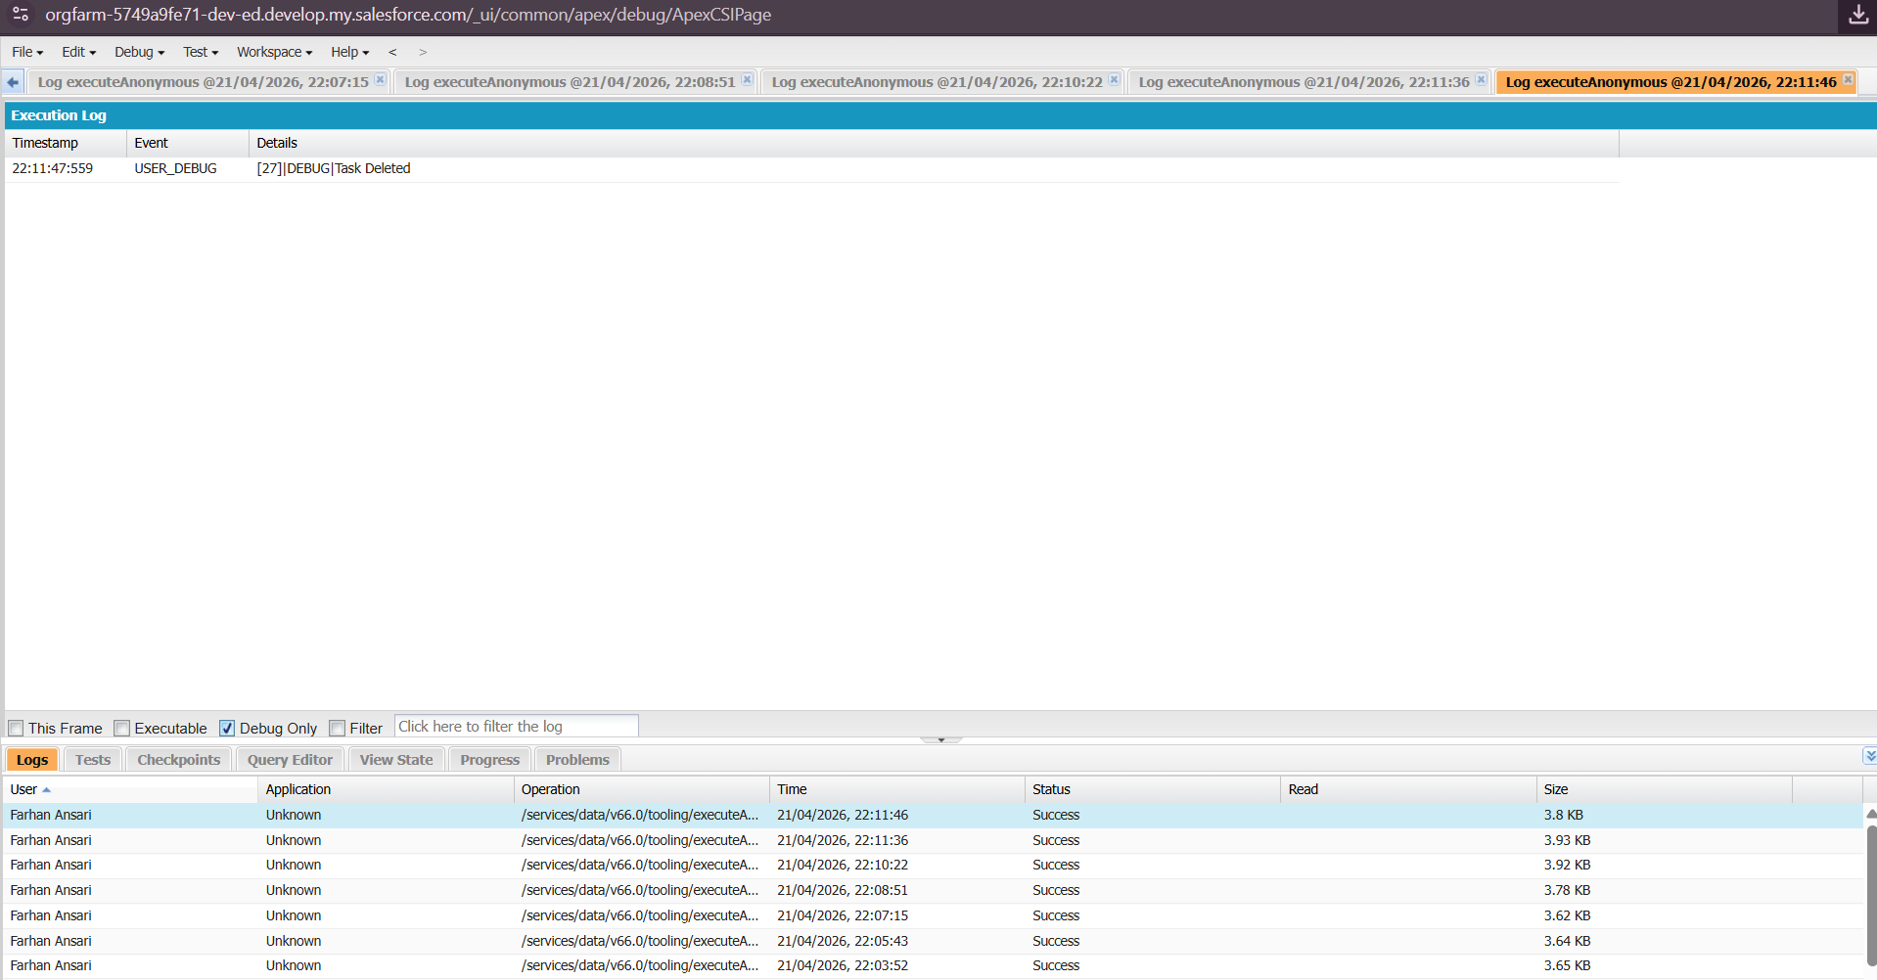
Fig 12.2: Debug Log – Task Deleted

Observations
- Custom object created successfully
- Fields (Status, Priority) added correctly
- Apex class implemented successfully
- CRUD operations executed correctly
- Debug logs verified all operations

Advantages
- Easy to manage tasks
- Automation using Apex
- No complex database setup
- Scalable cloud platform

Limitations
- Requires internet connectivity
- Debugging requires understanding of logs
- Limited UI without frontend

Conclusion
In this practical, we successfully implemented a Task Management System using Salesforce. We created a custom object, added fields, and performed CRUD operations using Apex. This provided hands-on experience in Salesforce development and cloud-based application building.

